**Worksheet 3**

**Student Name:Ritika Rana UID: 19BCA1126**

**Branch: UIC Section /Group :B/2**

**Semester: 6th Date of Performance:04/03/22**

**Subject Name : MICROPROCESSOR AND INTERFACING LAB Subject Code:CAP-356**

**1.Aim/Overview of the practical: A register B contains the data 42H at location and Register C consist of 35H. Write a program to add two 8 bit numbers without carry and store the result at 3002H.**

**2Task to be done:**The user has to add two 8 bit numbers without carry and store the result at 3002H.

**3. Hardware Required:**8085 Microprocessor

1. **Program:**

**LXI H, 3000H**

**MOV A,M**

**INX H**

**MOV B,M**

**ADD B**

**INX H**

**MOV M, A**

**HLT**

1. **Observations:**

LXI is used to load the 16-bit address into the register pair.

Mov is used to for protecting the power supply circuit from surges by changing its resistance.

**6. Calculations:**

For value at 3000H:

Value = 42H

Binary conversion of 42 = 0100 0010

For value at 3001H:

Value = 35

Binary conversion of 35 = 0011 0101

The final result after addition:

Value stored at 3002H=0111 0111=> Up on conversion = 77

1. **Output:**

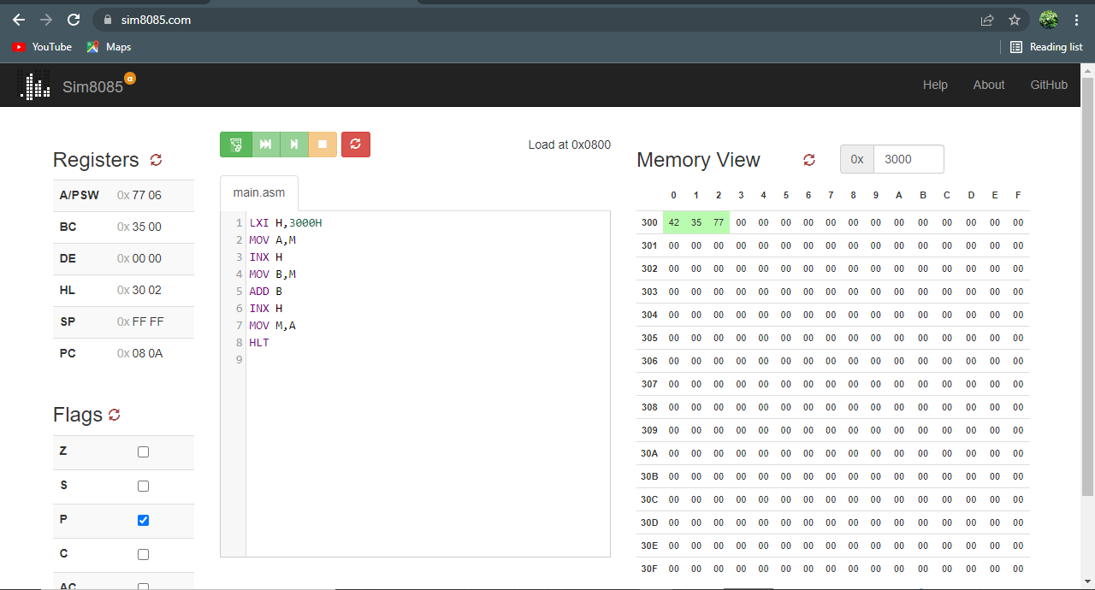

**Evaluation Grid (To be created as per the SOP and Assessment guidelines by the faculty):**

|  |  |  |  |
| --- | --- | --- | --- |
| **S. No** | **Parameter** | **Marks obtained** | **Maximum marks** |
| **1.** | **Worksheet** |  | **10** |
| **2.** | **Post lab Questions** |  | **5** |
| **3.** | **Pree lab Questions** |  | **5** |